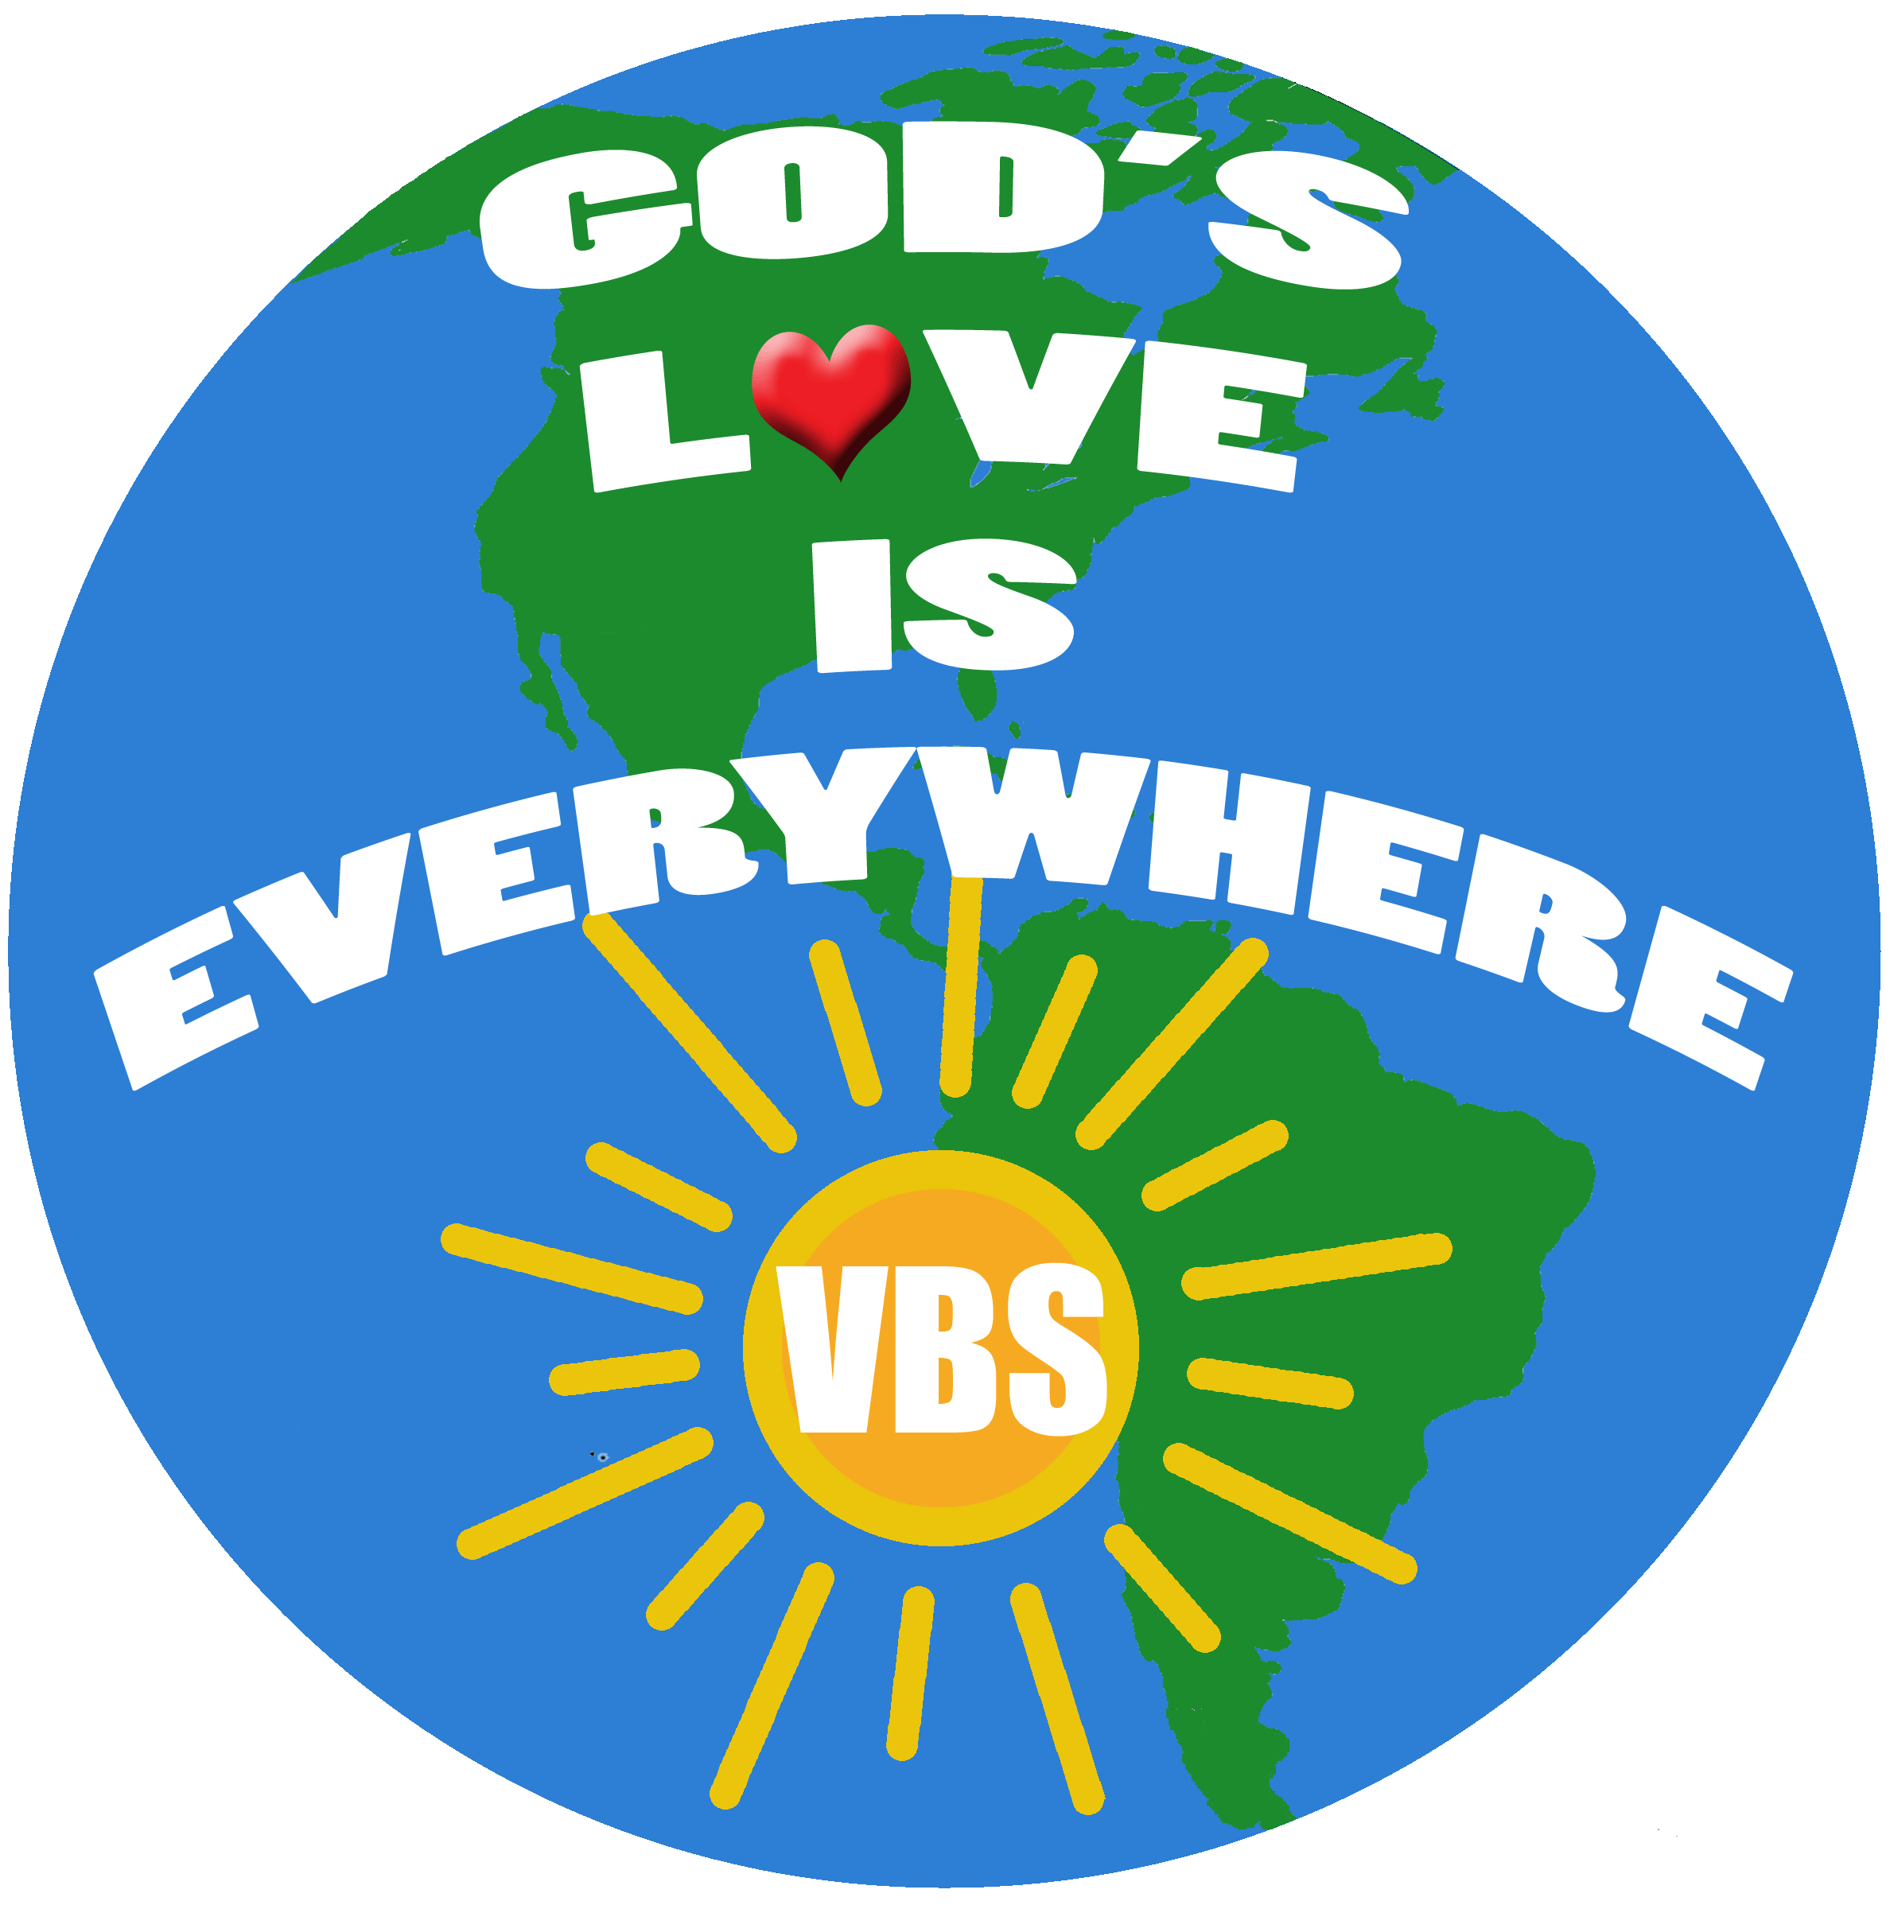
Location
Name of Church
Address
City, State

Date and Time
Date
Time

Location
Name of Church
Address
City, State

Date and Time
Date
Time

Location
Name of Church
Address
City, State

Date and Time
Date
Time

Location
Name of Church
Address
City, State

Date and Time
Date
Time

We’ll celebrate the week with a picnic at TIME on DATE,
and the VBS kids will sing at the TIME service on Sunday, DATE.
Registration is FREE! Forms can be picked up or downloaded
from our website & returned to the Church anytime. Invite a friend!
For more information, call PHONE or go to WEBSITE.

We’ll celebrate the week with a picnic at TIME on DATE,
and the VBS kids will sing at the TIME service on Sunday, DATE.
Registration is FREE! Forms can be picked up or downloaded
from our website & returned to the Church anytime . Invite a friend!
For more information, call PHONE or go to WEBSITE.

We’ll celebrate the week with a picnic at TIME on DATE,
and the VBS kids will sing at the TIME service on Sunday, DATE.
Registration is FREE! Forms can be picked up or downloaded from
our website & returned to the Church anytime. Invite a friend!
For more information, call PHONE or go to WEBSITE.

NAME of CHURCH Invites You!
Join us for Vacation Bible School as we travel to discover that
God’s L♥ve is Everywhere!
Description of Weekly Unit

We’ll celebrate the week with a picnic at TIME on DATE,
and the VBS kids will sing at the TIME service on Sunday, DATE.
Registration is FREE! Forms can be picked up or downloaded from
our website & returned to the Church anytime. Invite a friend!
For more information, call PHONE or go to WEBSITE.

For more information, call PHONE or go to WEBSITE.
For more information, call PHONE or go to WEBSITE.

NAME of CHURCH Invites You!
Join us for Vacation Bible School as we travel to discover that
God’s L♥ve is Everywhere!
Description of Weekly Unit

NAME of CHURCH Invites You!
Join us for Vacation Bible School as we travel to discover that
God’s L♥ve is Everywhere!
Description of Weekly Unit

NAME of CHURCH Invites You!
Join us for Vacation Bible School as we travel to discover that
God’s L♥ve is Everywhere!
Description of Weekly Unit

